# Project Design Phase-III

**Data Flow Diagrams & User Stories**

|  |  |
| --- | --- |
| Date | 31 October 2022 |
| Team ID | PNT2022TMID34691 |
| Project Name | Inventory Management system for Retailers |

# Data Flow Diagrams:

A Data Flow Diagram (DFD) is a traditional visual representation of the information flows within a system. A neat and clear DFD can depict the right amount of the system requirement graphically. It shows how data enters and leaves the system, what changes the information, and where data is stored.

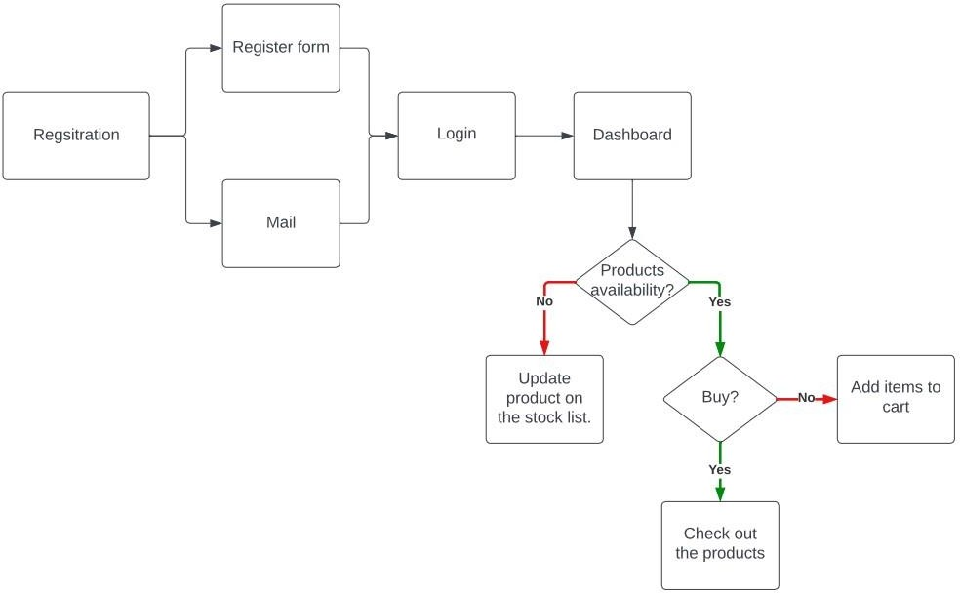

# User Stories

Use the below template to list all the user stories for the product.

|  |  |  |  |  |  |  |
| --- | --- | --- | --- | --- | --- | --- |
| **User Type** | **Functional Requirement (Epic)** | **User Story Number** | **User Story / Task** | **Acceptance criteria** | **Priority** | **Release** |
| Customer (Web user) | Registration | USN-1 | As a user, I can register for the application by entering my email, password, and confirming my password. | I can access my account / dashboard | High | Sprint-1 |
|  |  | USN-2 | As a user, I can register for the application through E-mail | I can access my account / dashboard | Medium | Sprint-1 |
|  | Confirmation | USN-3 | As a user, I will receive confirmation email once I have registered for the application | I can get confirmation for my email and password and create  authenticated account. | Medium | Sprint-1 |
|  | Login | USN-4 | As a user, I can log into the application by entering email & password | I can log onto the application with  verified email and password | High | Sprint-1 |
|  | Dashboard | USN-5 | As a user, I can view the products which are available | Once I log on to the application, I can view products to  buy. | High | Sprint-2 |

|  |  |  |  |  |  |  |
| --- | --- | --- | --- | --- | --- | --- |
| **User Type** | **Functional Requirement (Epic)** | **User Story Number** | **User Story / Task** | **Acceptance criteria** | **Priority** | **Release** |
|  | Add items to cart | USN-6 | As a user, I can add the products I wish to buy to the carts. | As a user, I can buy any products or add it to my cart for buying it later. | Medium | Sprint-2 |
|  | Stock Update | USN-7 | As a user, I can add products which are not available in the dashboard to the stock list. | If any of the products which are not available, as a user I can update the inventory and send mail to the owner. | Medium | Sprint-3 |
| Customer Care Executive | Request to Customer Care | USN-8 | As a user, I can contact the Customer Care Executive and request any services I want from the customer care. | As a user, I can contact Customer Care and get support from them. | Low | Sprint-4 |
| Administrator | Contact Administrator | USN-9 | I can be able to report any difficulties I experience as a report | As user, I can give my support in my possible ways to administrator and the administration. | Medium | Sprint-4 |